UNIVERSITY OF PETROLEUM AND ENERGY STUDIES


Student Name: Deepanshi Shukla
Sap ID: - 590021964
Batch: B10
Course: B. Tech (CSE)
SUBJECT: python Programming lab
Experiment: 3
Submitted to:
Kamakshi Rautela

Python Programming Laboratory
Experiment 3: Loops
1.Find a factorial of given number.
Code:
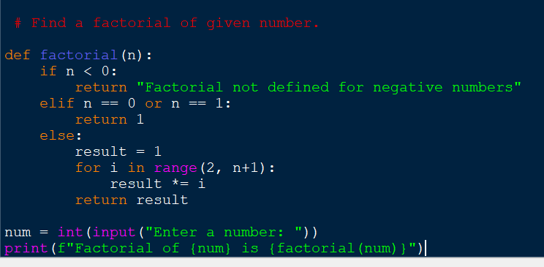
Output:
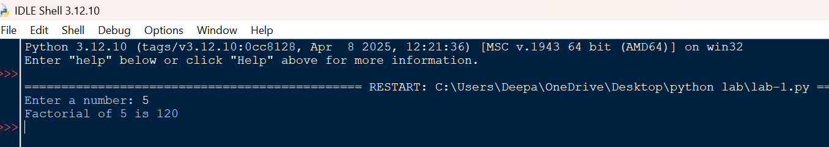
2. Find whether the given number is Armstrong number.
Code:
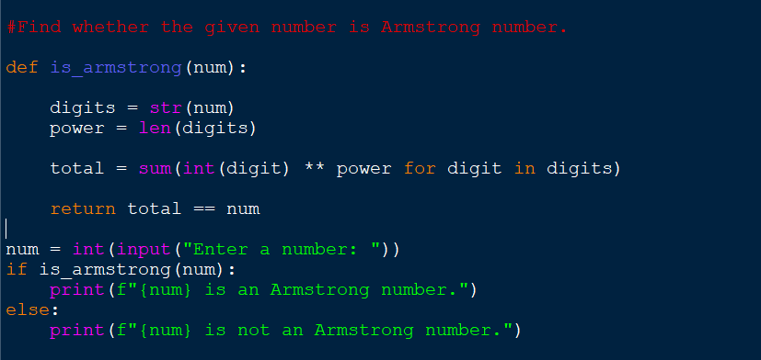
Output:
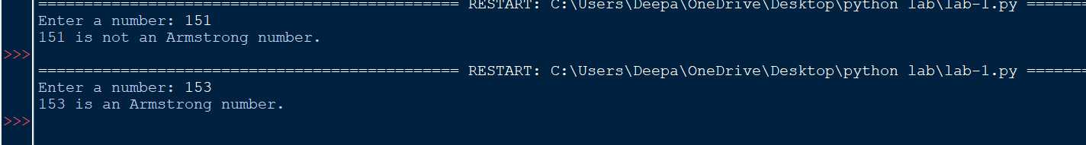
3. Print Fibonacci series up to given term.
Code:
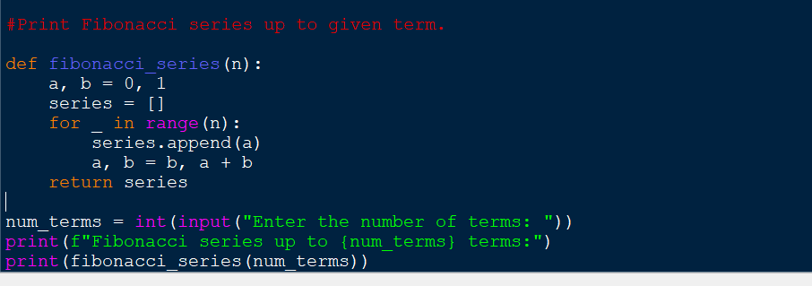
Output:
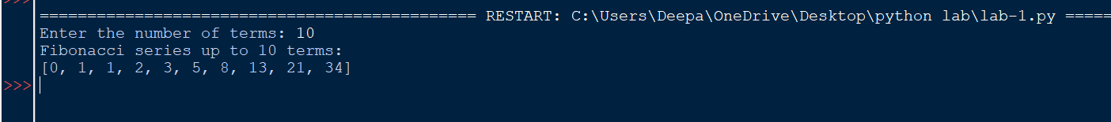
4. Write a program to find if given number is prime number or not.
Code:
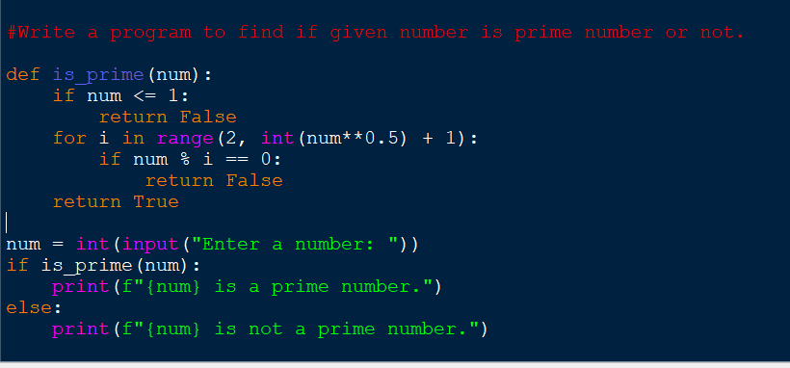
Output:
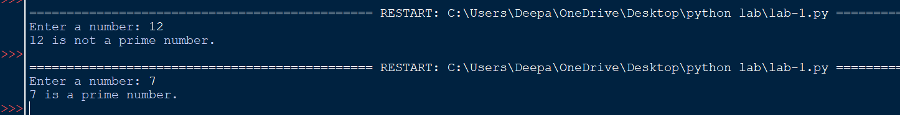
5.Check whether given number is palindrome or not.
Code:
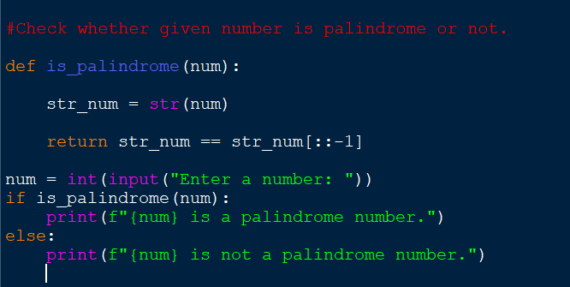
Output:
6. Write a program to print sum of digits.
Code:
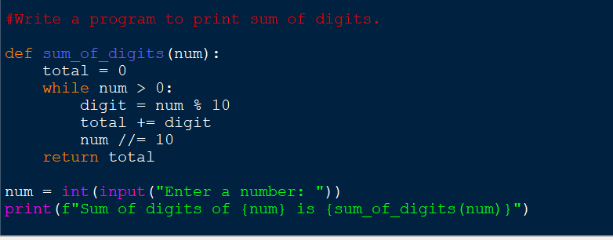
Output:
7. Count and print all numbers divisible by 5 or 7 between 1 to 100.
Code:
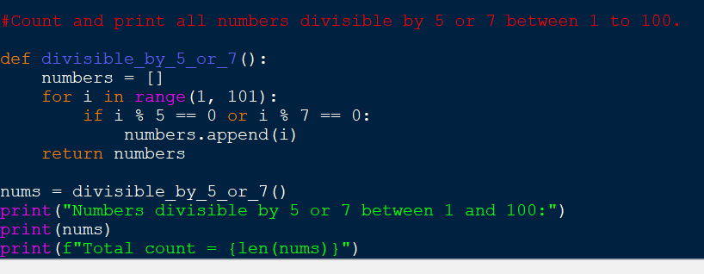
Output:
8. Convert all lower cases to upper case in a string.
Code: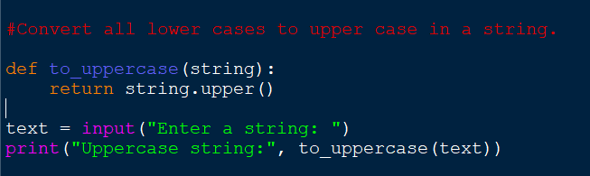
Output:
9.Print the table for a given number:
5 * 1 = 5
5 * 2 = 10………..
Code: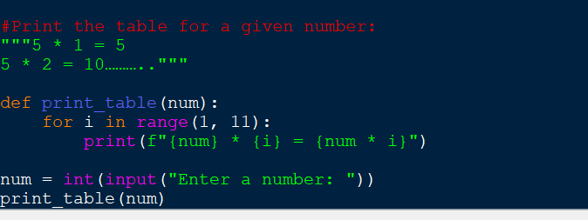
Output: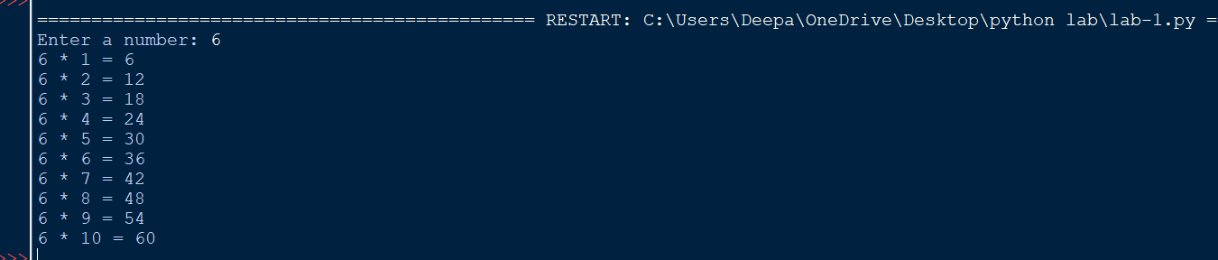

10.Write a program to print the following pattern
123454321
1234 *4321
123 * * 321
12 * * * 21
1 * * * * 1
Code: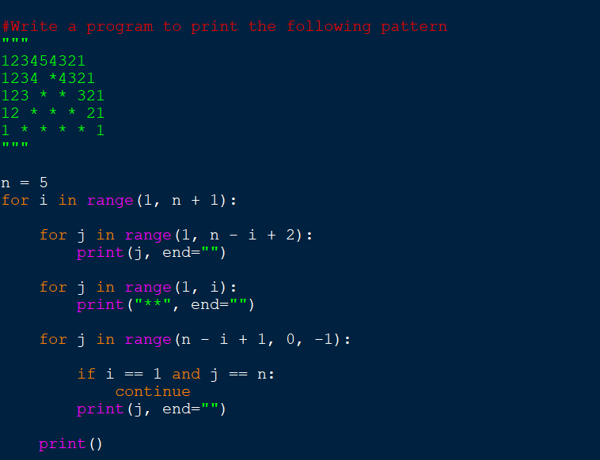Output: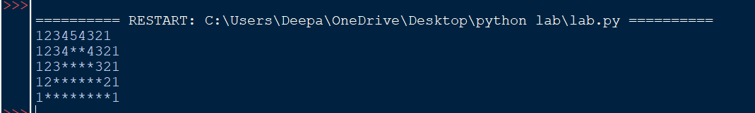
11.Write a program to print the sum of the following series
1+ ½ + 1/3 + ¼ +….+1/n
Code: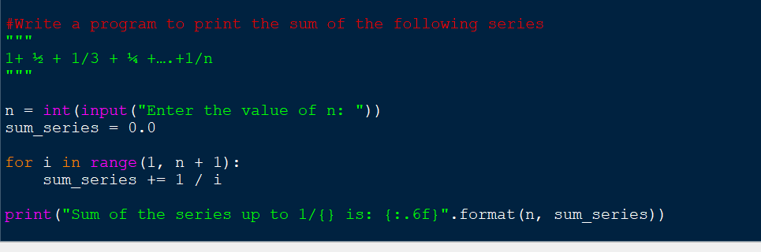
Output:

